EXPERIMENT-15
15) Perform basic Image Handling and processing operations on the image is to read an image in python and detect the corners in the image using Harris Corner Detection function.
a)CODE
import cv2
import numpy as np
from tkinter import Tk, filedialog

root = Tk()
root.withdraw()

file = filedialog.askopenfilename(
title="Select Image",
filetypes=[("Image Files", "*.jpg *.jpeg *.png")]
)

img = cv2.imread(file)

if img is None:
print("Image not found")
else:
gray = cv2.cvtColor(img, cv2.COLOR_BGR2GRAY)
gray = np.float32(gray)

corners = cv2.cornerHarris(gray, 2, 3, 0.04)

img[corners > 0.01 * corners.max()] = [0, 0, 255]

cv2.imwrite(
r"C:\Users\Admin\Desktop\harris_corners.jpg",
img
)

cv2.imshow("Harris Corner Detection", img)

print("Harris Corner Detection completed successfully")
print("Saved on Desktop as harris_corners.jpg")

cv2.waitKey(0)
cv2.destroyAllWindows()

b) INPUT

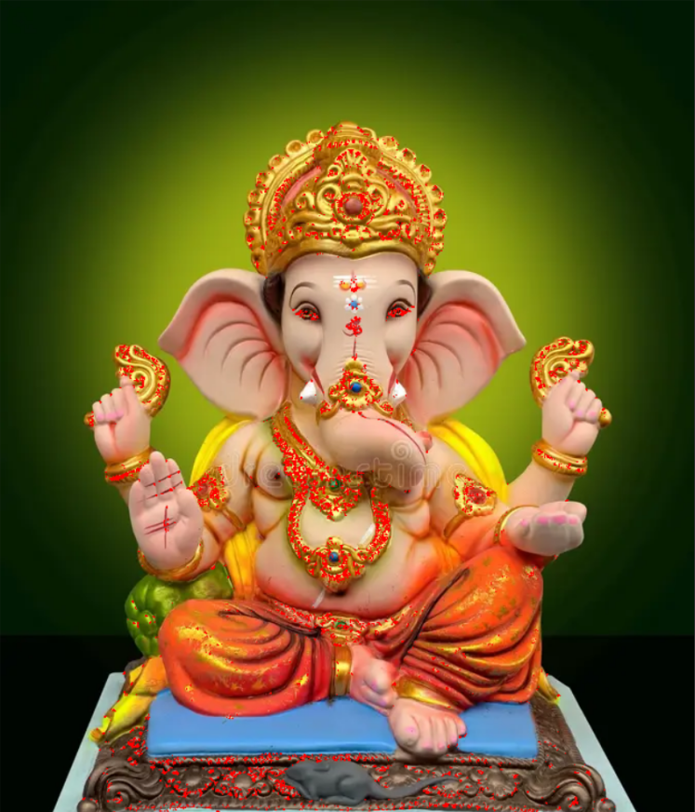
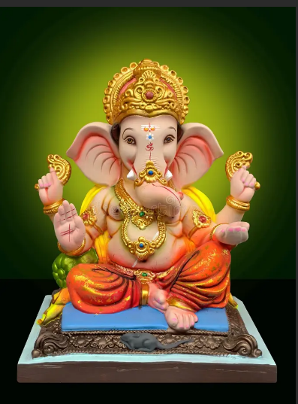

C)OUTPUT

